Pattern Processing using AI Practical File



COSCE60

Nikhil Gupta

2019UCO1719

COE Section 3

**Q1 Write a python program to implement a simple Chatbot.**

Code:

# %%

import json

import requests

# %%

def chatbot():

print("Hi! I'm a weather prediction chatbot")

api_key = "f37d0c3cb6c045218e1152633232504"

while(1):

print("Which city would you like the weather forcast for? Type 'exit' to quit")

city = input().lower()

if(city=="exit"):

break

url = f"https://api.weatherapi.com/v1/forecast.json?key={api_key}&q={city}"

response = requests.get(url)

data = json.loads(response.text)

if len(data)>1:

temp = data["current"]["temp_c"]

description = data["current"]["condition"]["text"]

humidity = data["current"]["humidity"]

wind_speed = data["current"]["wind_kph"]

print(f"The weather in {city.title()} is {description}, with a temperature of {temp}°C , humidity of {humidity}%, and wind speed of {wind_speed} km/h.")

print()

else:

print("City not found. Please try again.")

print()

print("Thank you for using the chatbot.")

# %%

chatbot()

# %%

Output:

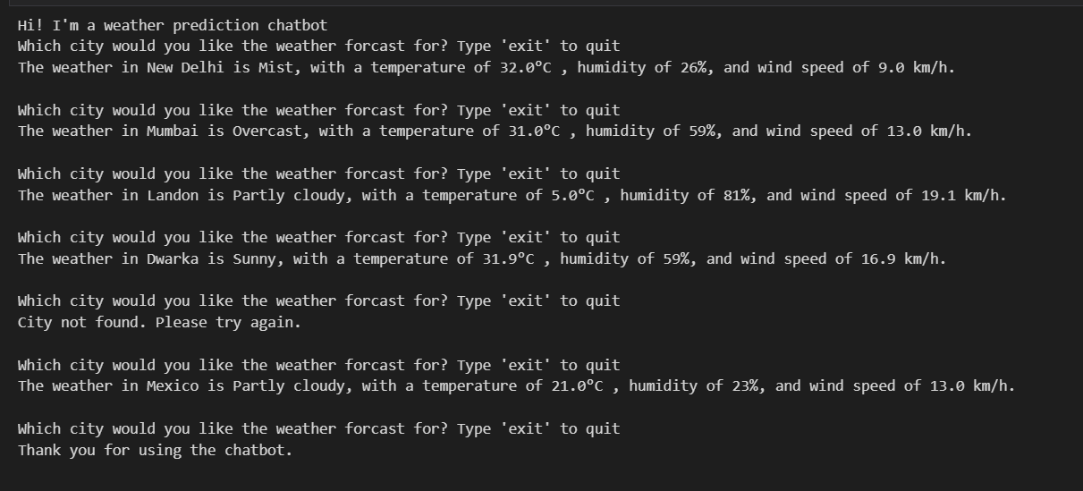

Q2 Write a program to implement k-means clustering from scratch.

Code:

# %%

import numpy as np

import pandas as pd

import matplotlib.pyplot as plt

from sklearn.datasets import make_blobs

# %%

X,Y = make_blobs(n_samples=500,n_features=2,centers=5,random_state=3)

# %%

plt.figure(0)

plt.scatter(X[:,0],X[:,1],c=Y)

plt.show()

# %%

k = 5

color = ["green","red","yellow","blue","orange"]

clusters = {}

for i in range(k):

center = 10*(2*np.random.random((X.shape[1],))-1)

points = []

cluster = {

"center":center,

"points":points,

"color":color[i]

}

clusters[i] = cluster

# %%

print(clusters)

# %%

def distance(x1,x2):

return np.sqrt(np.sum((x1-x2)**2))

def assignPointsToCluster(clusters):

for i in range(X.shape[0]):

clust_x = X[i]

dist = []

for kx in range(k):

d = distance(clust_x,clusters[kx]['center'])

dist.append(d)

idx = np.argmin(dist)

clusters[idx]['points'].append(clust_x)

def updateCluster(clusters):

for kx in range(k):

pts = np.array(clusters[kx]['points'])

if(pts.shape[0]>0):

new_centers = np.mean(pts,axis=0)

clusters[kx]['center'] = new_centers

clusters[kx]['points'] = []

def plotClusters(clusters):

plt.figure()

for kx in range(k):

pts = np.array(clusters[kx]['points'])

try:

plt.scatter(pts[:,0],pts[:,1],color=clusters[kx]['color'])

except:

pass

cent = clusters[kx]['center']

plt.scatter(cent[0],cent[1],color='black',marker="*")

# %%

epoch = 5

for i in range(epoch):

assignPointsToCluster(clusters)

plotClusters(clusters)

updateCluster(clusters)

# %%

Output: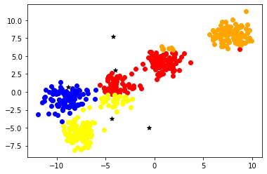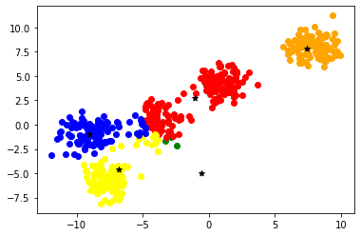

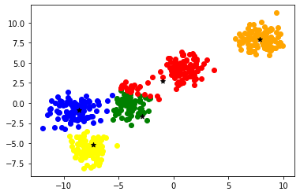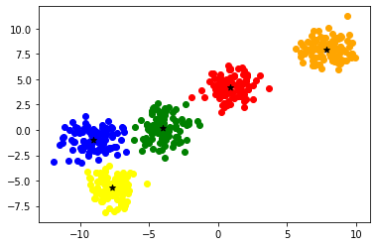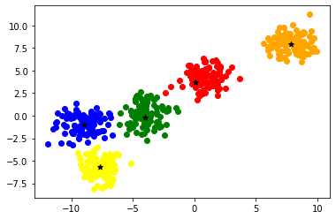

Q3 Generating samples of Gaussian (normal) distributions and plotting them for visualization

Code:

# %%

import numpy as np

import matplotlib.pyplot as plt

# %%

x_axis = np.arange(-100,100,0.1)

print(x_axis)

# %%

mean = np.mean(x_axis)

std = np.std(x_axis)

print(mean,std)

# %%

y_axis = 1/(std * np.sqrt(2 * np.pi)) * np.exp( - (x_axis - mean)**2 / (2 * std**2) )

# %%

plt.plot(x_axis,y_axis,linewidth=3, color='r')

plt.show()

# %%

Output:

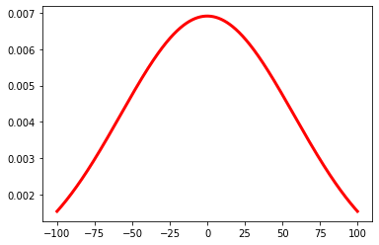

Q4 Implement Decision Tree algorithms.

import matplotlib.pyplot as plt

from sklearn import datasets

from sklearn.metrics import confusion_matrix

from sklearn.metrics import accuracy_score

from sklearn.model_selection import train_test_split

from sklearn.tree import export_graphviz

import graphviz

from sklearn.tree import DecisionTreeClassifier

iris = datasets.load_iris()

X = iris.data

y = iris.target

X_train, X_test, y_train, y_test = train_test_split(X, y, random_state = 0, test_size = 0.2)

tree = DecisionTreeClassifier(max_depth = 5)

tree.fit(X_train, y_train)

tree_predictions = tree.predict(X_test)

cm = confusion_matrix(y_test, tree_predictions)

print(cm)

score =accuracy_score(tree_predictions, y_test)

print(score)

tree_formed = export_graphviz(tree, out_file = None, feature_names = iris.feature_names, class_names = iris.target_names, filled = True)

graph = graphviz.Source(tree_formed, format="png")

graph

Output:

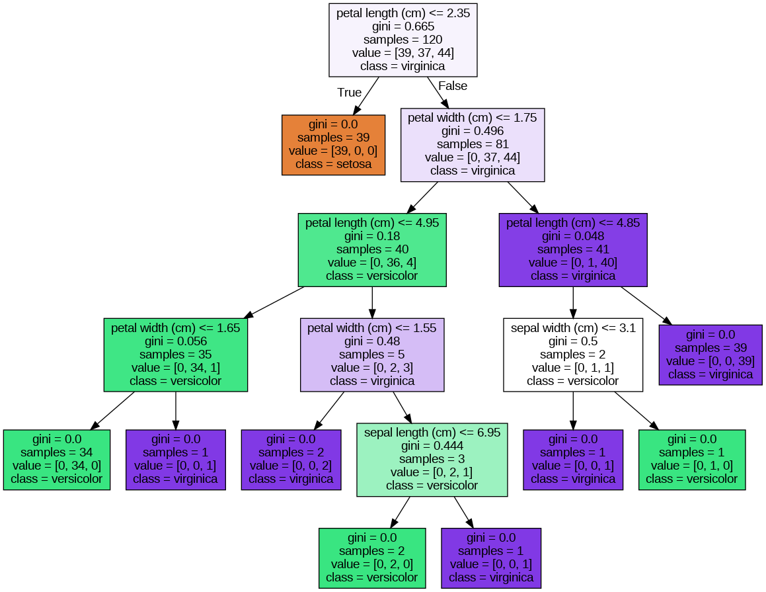

Q5 Implement SVM.

Code:

# %% [markdown]

# ### Generate Dataset

# %%

from sklearn.datasets import make_classification

import matplotlib.pyplot as plt

from mpl_toolkits.mplot3d import Axes3D

import numpy as np

# %%

X,Y = make_classification(n_classes=2,n_samples=1000,n_clusters_per_class=1,random_state=3,n_features=2,n_informative=2,n_redundant=0)

# %%

plt.scatter(X[:,0],X[:,1],c=Y)

plt.show()

# %%

plt.scatter(X[:,0],X[:,1],c=Y)

plt.show()

# %%

def make_meshgrid(x, y, h=.02):

x_min, x_max = x.min() - 1, x.max() + 1

y_min, y_max = y.min() - 1, y.max() + 1

xx, yy = np.meshgrid(np.arange(x_min, x_max, h), np.arange(y_min, y_max, h))

return xx, yy

def plot_contours(ax, clf, xx, yy, **params):

Z = clf.predict(np.c_[xx.ravel(), yy.ravel()])

Z = Z.reshape(xx.shape)

out = ax.contourf(xx, yy, Z, **params)

return out

def plot(model, X,Y,title):

fig, ax = plt.subplots()

xx, yy = make_meshgrid(X[:,0],X[:,1])

plot_contours(ax, model, xx, yy, cmap=plt.cm.coolwarm, alpha=0.8)

ax.scatter(X[:,0], X[:,1], c=Y, cmap=plt.cm.coolwarm, s=20, edgecolors='k')

ax.set_title(title)

plt.show()

# %%

from sklearn import svm

# %%

svc = svm.SVC(kernel='linear')

svc.fit(X,Y)

print(svc.score(X,Y))

plot(svc,X,Y,"Linear kernal")

# %%

# RBF Kernel

svc = svm.SVC()

svc.fit(X,Y)

print(svc.score(X,Y))

plot(svc,X,Y,"RBF kernal")

# %%

# Polynomial Kernel

svc = svm.SVC(kernel='poly')

svc.fit(X,Y)

print(svc.score(X,Y))

plot(svc,X,Y,"Poly kernal")

# %%

def custom_kernel(x1,x2):

return np.square(np.dot(x1,x2.T))

svc = svm.SVC(kernel=custom_kernel)

svc.fit(X,Y)

print(svc.score(X,Y))

plot(svc,X,Y,"Custom kernal")

# %%

Output: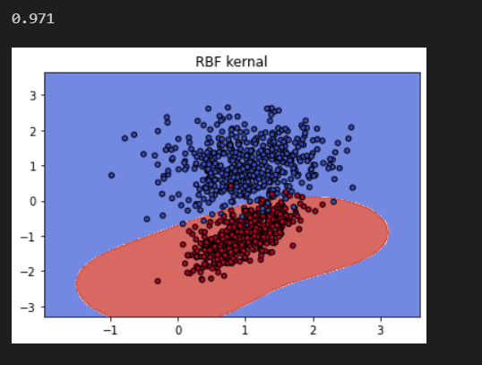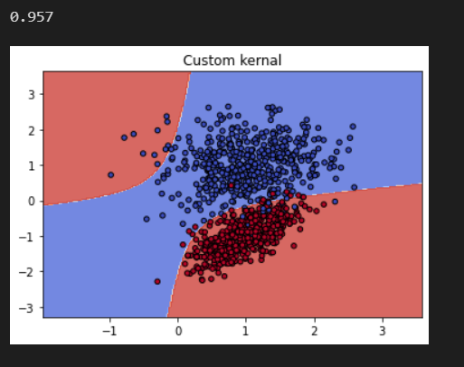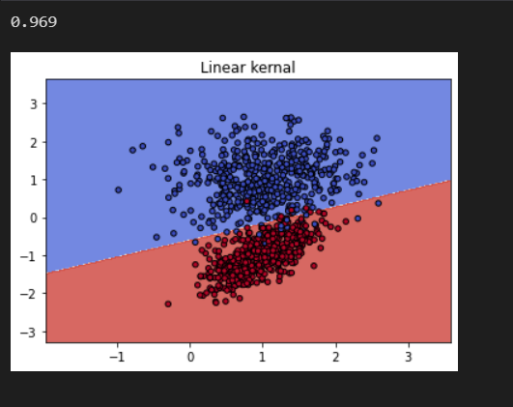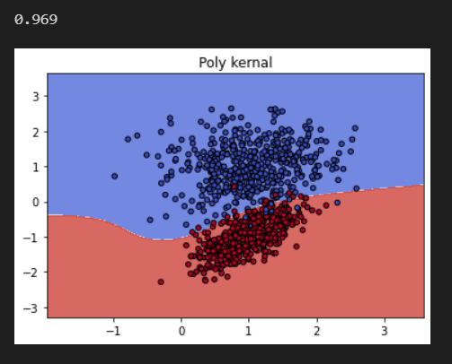

Q6 Implement agglomerative Hierarchical clustering.

Code:

from clustimage import Clustimage

cl = Clustimage()

X = cl.import_example(data='mnist')

result = cl.fit_transform(X, cluster='agglomerative')

cl.dendrogram()

cl.plot(cmap='binary', labels=[1,2])

Output:

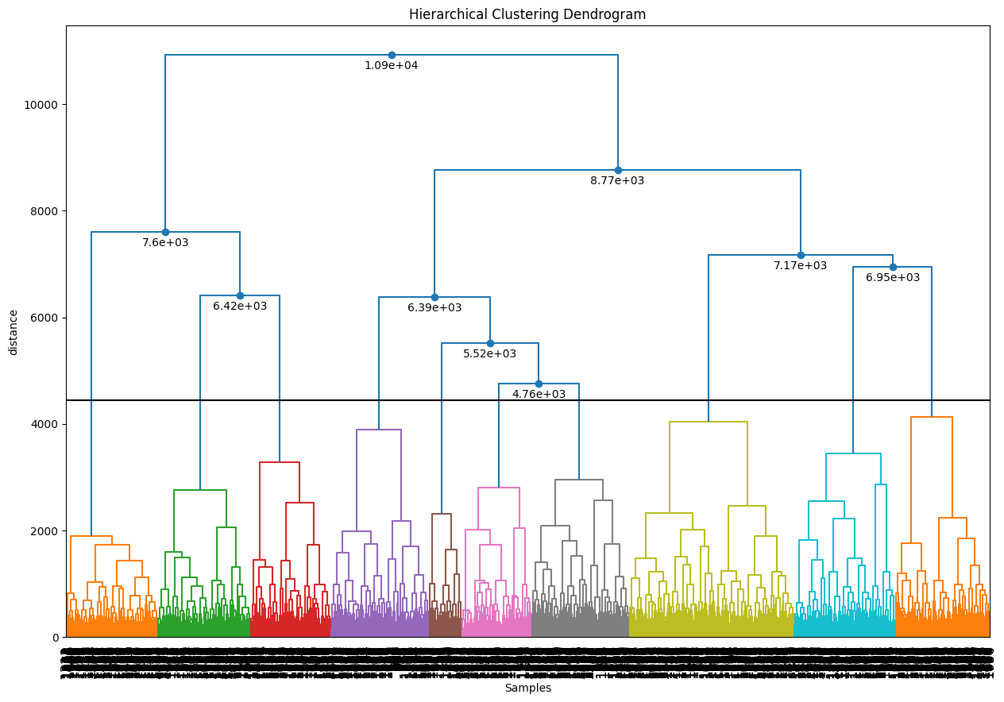

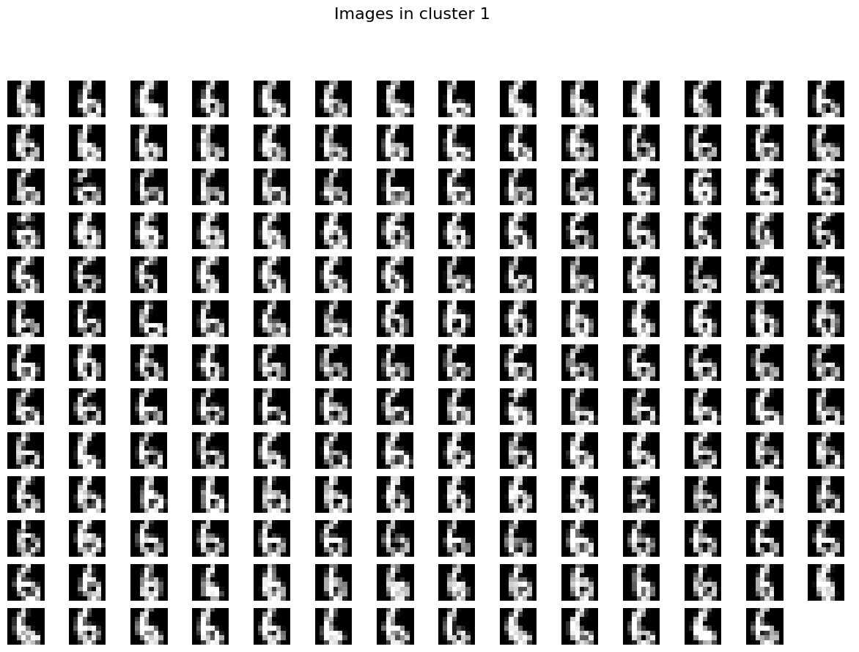

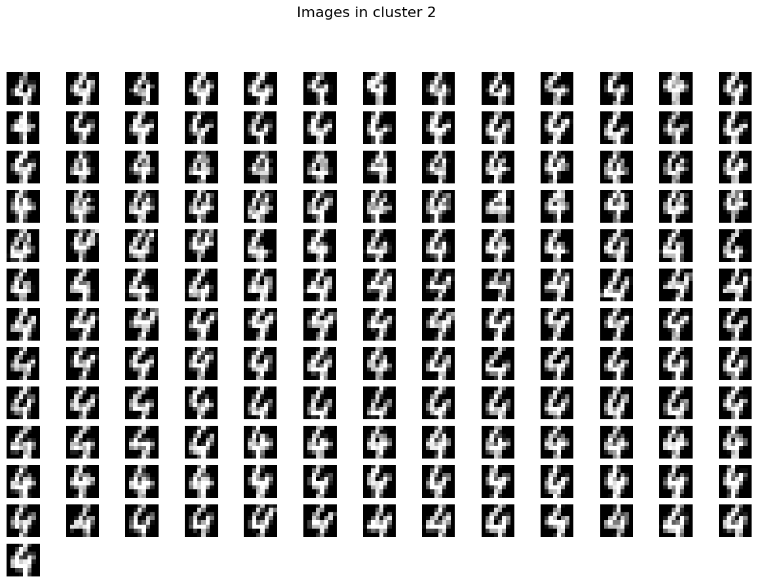

Q7 Implement Maximum-Likelihood estimation.

Code:

# %%

import numpy as np

import math

from scipy.optimize import minimize

# %%

mean = 10

std = 20

# %%

s = np.random.normal(mean, std, 3000)

# %%

def likelihood(mean, std, x):

return (1 / math.sqrt(2 * math.pi * std**2)) * np.exp(-(x - mean)**2 / (2 * std**2))

def log_likelihood(mean, std, data):

return sum(np.log(likelihood(mean, std, x)) for x in data)

# %%

neg_log_likelihood = lambda mean: -log_likelihood(mean, std, s)

# %%

result = minimize(neg_log_likelihood, x0=0.0)

mean_mle = result.x[0]

print(mean_mle)

# %%

print("Difference between original mean and new mean", mean-mean_mle)

# %%

Output:

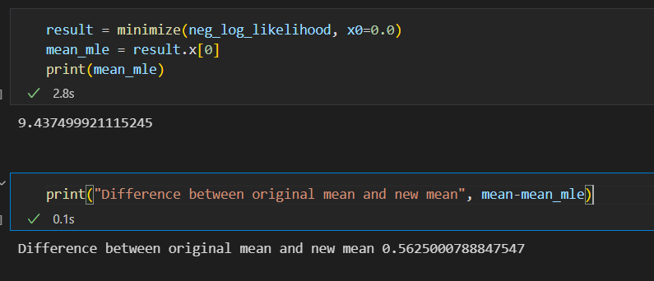

Q8 Implement Principal component analysis and use it for unsupervised learning

Code:

# %%

import pandas as pd

import numpy as np

import matplotlib.pyplot as plt

from sklearn.decomposition import PCA

from sklearn.cluster import AgglomerativeClustering

from sklearn.preprocessing import StandardScaler, normalize

from sklearn.metrics import silhouette_score

import scipy.cluster.hierarchy as shc

# %%

X = pd.read_csv('wine-clustering.csv')

X.fillna(method ='ffill', inplace = True)

# %%

scaler = StandardScaler()

X_scaled = scaler.fit_transform(X)

X_normalized = normalize(X_scaled)

X_normalized = pd.DataFrame(X_normalized)

# %%

pca = PCA(n_components = 2)

X_principal = pca.fit_transform(X_normalized)

X_principal = pd.DataFrame(X_principal)

X_principal.columns = ['P1', 'P2']

# %%

plt.figure(figsize =(8, 8))

plt.title('Visualising the data')

Dendrogram = shc.dendrogram((shc.linkage(X_principal, method ='ward')))

# %%

ac2 = AgglomerativeClustering(n_clusters = 2)

# Visualizing the clustering

plt.figure(figsize =(6, 6))

plt.scatter(X_principal['P1'], X_principal['P2'],

c = ac2.fit_predict(X_principal), cmap ='rainbow')

plt.show()

# %%

ac3 = AgglomerativeClustering(n_clusters = 3)

plt.figure(figsize =(6, 6))

plt.scatter(X_principal['P1'], X_principal['P2'],

c = ac3.fit_predict(X_principal), cmap ='rainbow')

plt.show()

# %%

ac4 = AgglomerativeClustering(n_clusters = 4)

plt.figure(figsize =(6, 6))

plt.scatter(X_principal['P1'], X_principal['P2'],

c = ac4.fit_predict(X_principal), cmap ='rainbow')

plt.show()

# %%

ac5 = AgglomerativeClustering(n_clusters = 5)

plt.figure(figsize =(6, 6))

plt.scatter(X_principal['P1'], X_principal['P2'],

c = ac5.fit_predict(X_principal), cmap ='rainbow')

plt.show()

# %%

ac6 = AgglomerativeClustering(n_clusters = 6)

plt.figure(figsize =(6, 6))

plt.scatter(X_principal['P1'], X_principal['P2'],

c = ac6.fit_predict(X_principal), cmap ='rainbow')

plt.show()

# %%

k = [2, 3, 4, 5, 6]

# Appending the silhouette scores of the different models to the list

silhouette_scores = []

silhouette_scores.append(

silhouette_score(X_principal, ac2.fit_predict(X_principal)))

silhouette_scores.append(

silhouette_score(X_principal, ac3.fit_predict(X_principal)))

silhouette_scores.append(

silhouette_score(X_principal, ac4.fit_predict(X_principal)))

silhouette_scores.append(

silhouette_score(X_principal, ac5.fit_predict(X_principal)))

silhouette_scores.append(

silhouette_score(X_principal, ac6.fit_predict(X_principal)))

# Plotting a bar graph to compare the results

plt.bar(k, silhouette_scores)

plt.xlabel('Number of clusters', fontsize = 20)

plt.ylabel('S(i)', fontsize = 20)

plt.show()

# %%

Output:

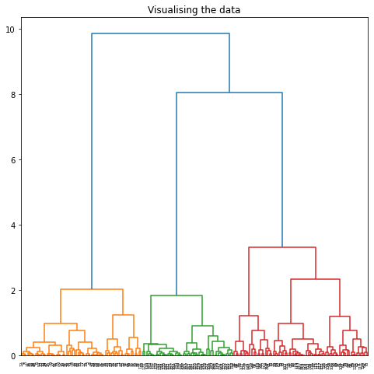

For n_clusters = 2 For n_clusters = 3 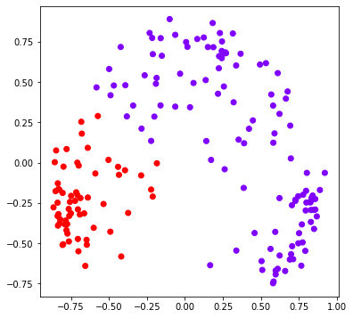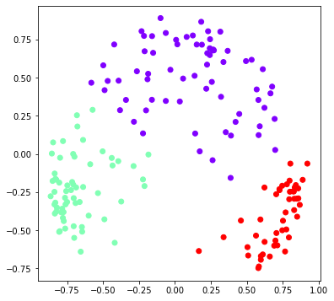

For n_clusters = 4 For n_clusters = 5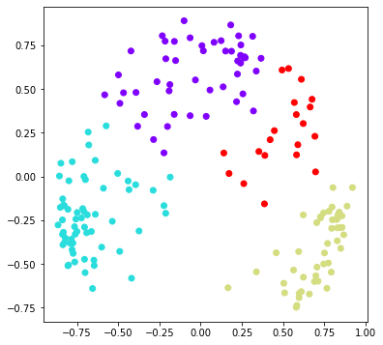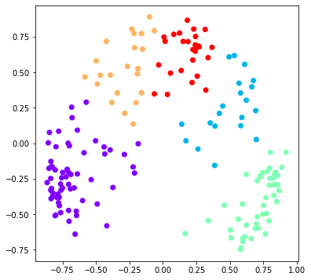

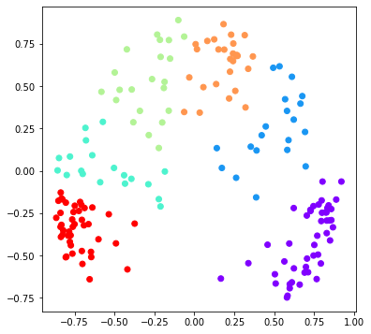

For n_clusters = 6

Plot of n_clusters and score